**Hands-on 2 : ReactJS-HOL**

1. Create a React project named “StudentApp” type the following command in terminal of Visual studio:



1. Create a new folder under src folder with the name “Components”. Add a new file named “Home.js” and type the following code in Home.js

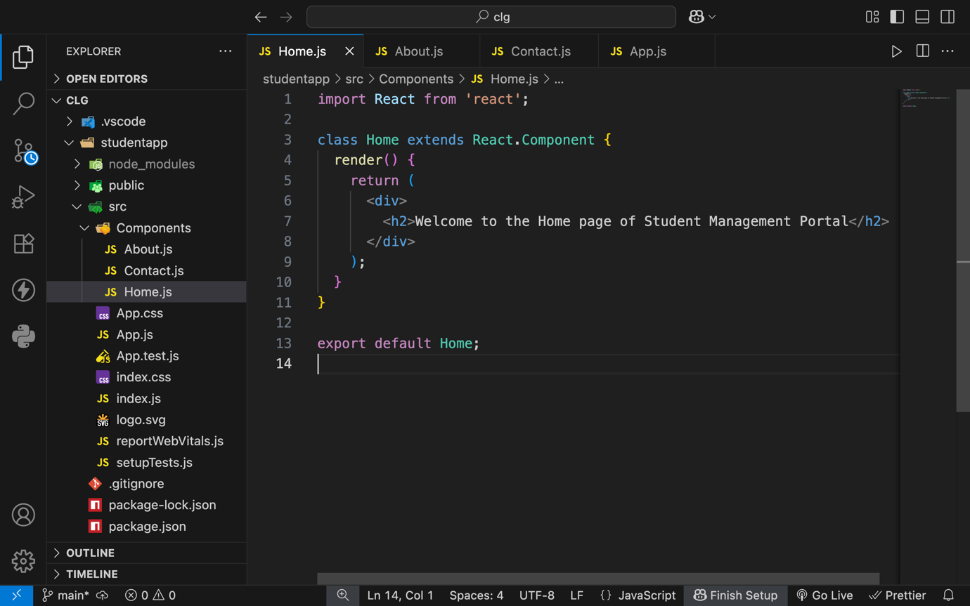

1. Under Src folder add another file named “About.js” and “Contact.js”.
2. Repeat the same steps for Creating “About” and “Contact” component by adding a new file as ”About.js”, “Contact.js” under “src” folder and edit the code as mentioned for “Home” Component.

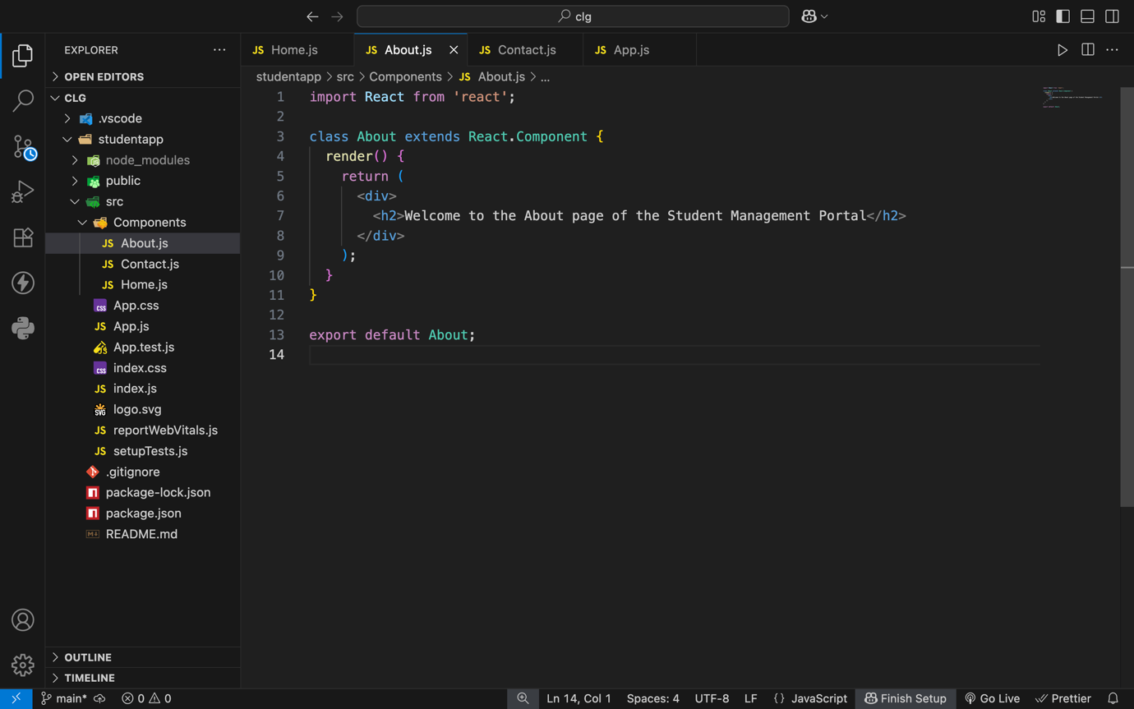

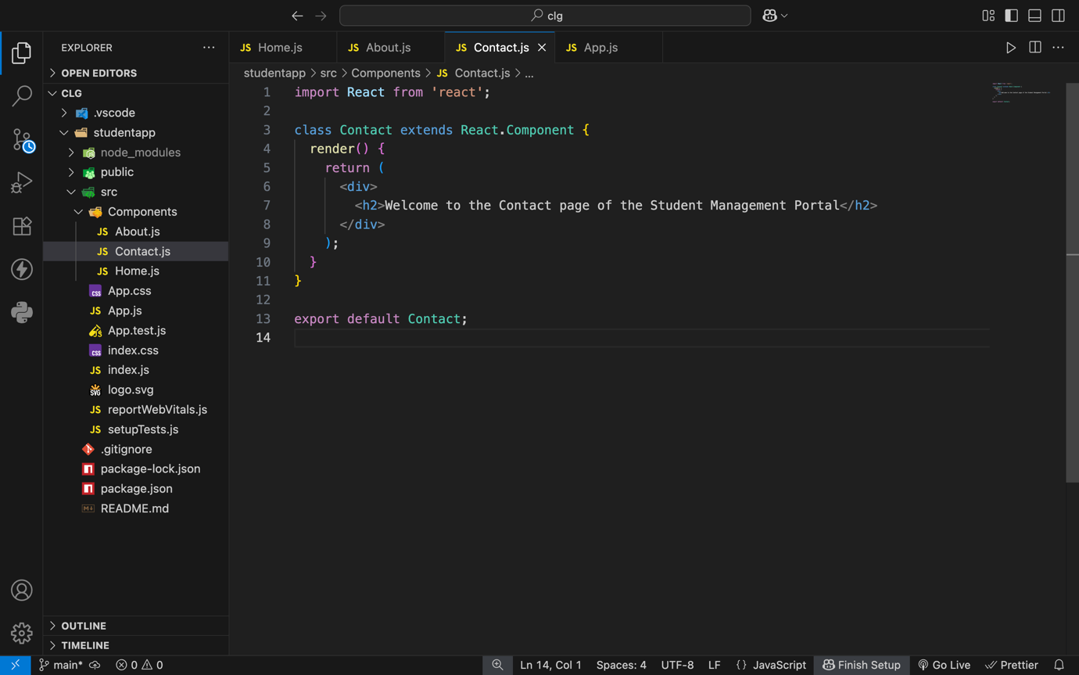

1. Edit the App.js to invoke the Home, About and Contact component as follows:

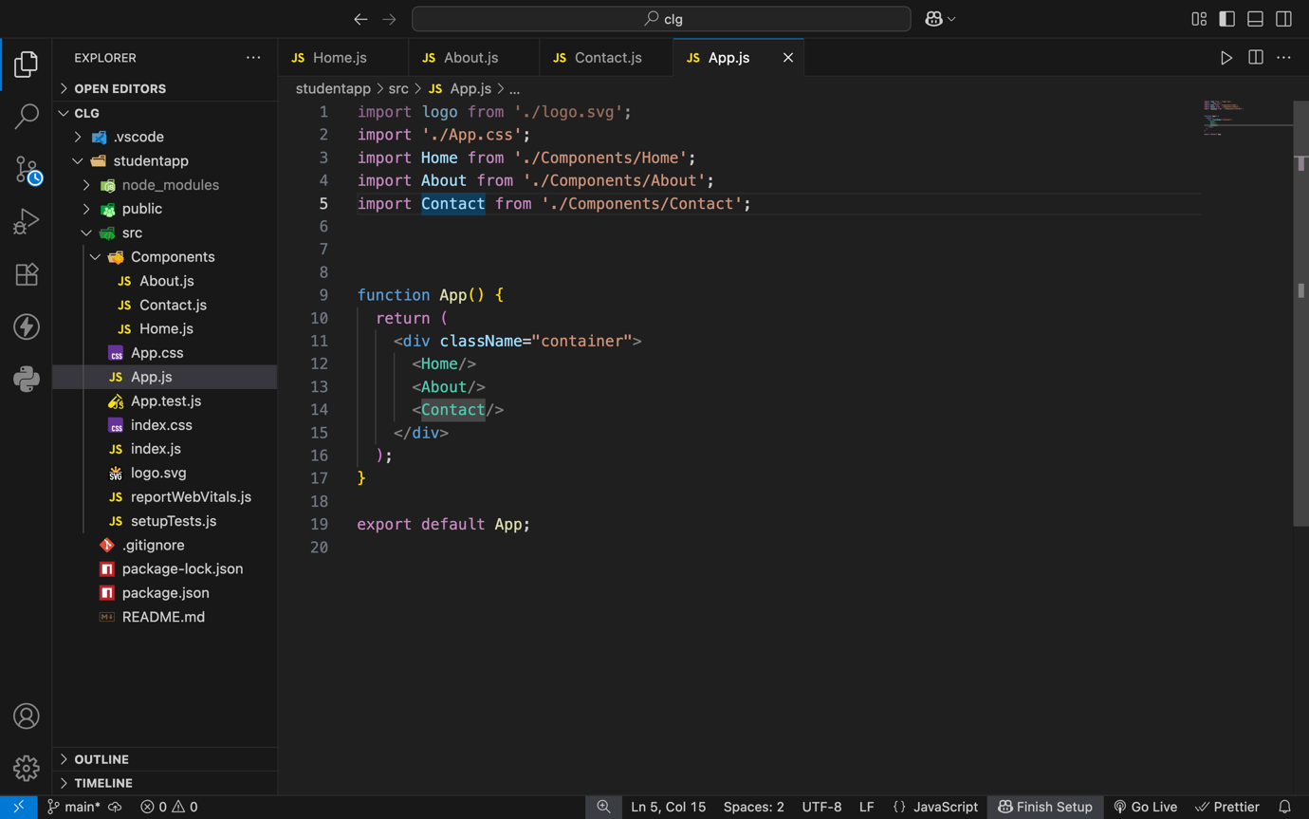

1. In command Prompt, navigate into StudentApp and execute the code by typing the following command:

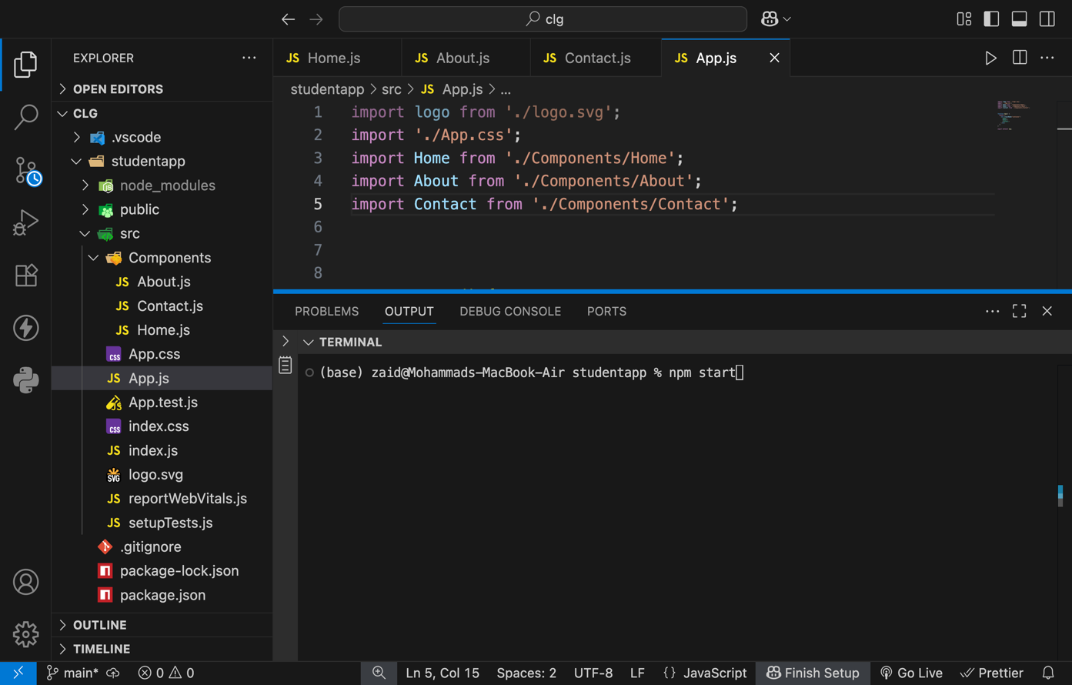

1. Open browser and type “localhost:3000” in the address bar:

